**BANK LOAN REPORT QUERY**

1. **KEY PERFORMANCE INDICATOR**

**Total Loan Applications**

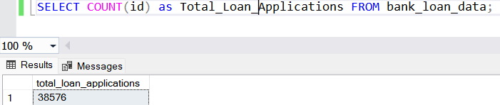

**Month To Date - MTD**

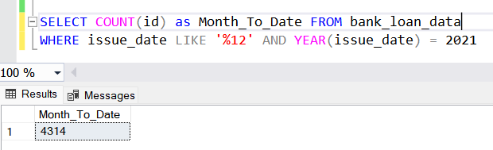

**Previous Month To Date - PMTD**

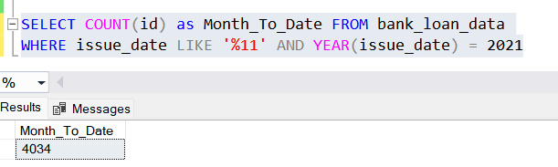

**Total Funded Amount**

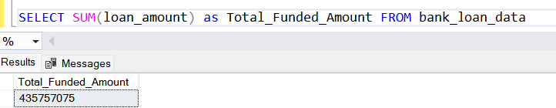

**MTD_Total_Funded_Amount**

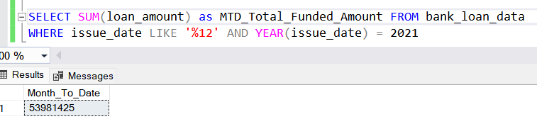

**PMTD_Total_Funded_Amount**

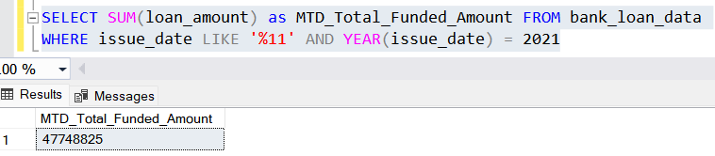

**Total_Amount_Received**

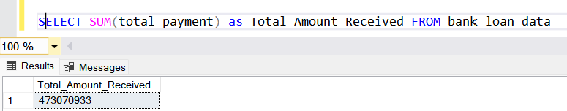

**MTD_Total_Amount_Received**

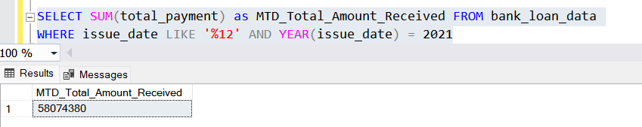

**PMTD_Total_Amount_Received**

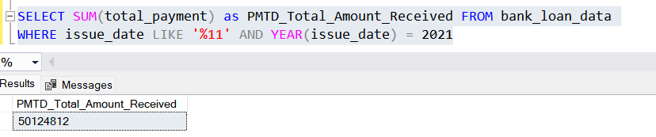

**Average_Interest_Rate**

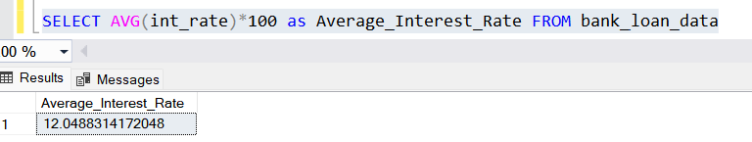

**MTD_Average_Interest_Rate**

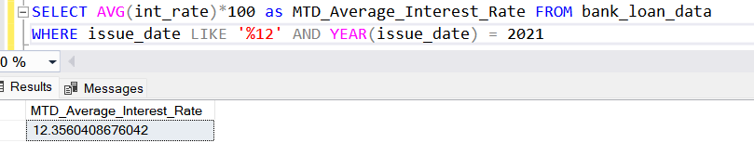

**PMTD_Average_Interest_Rate**

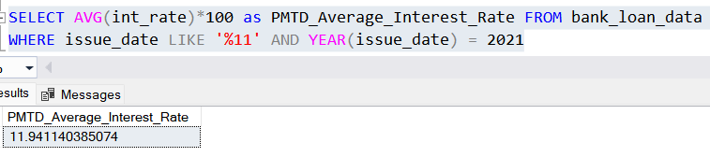

**Avg_DTI**

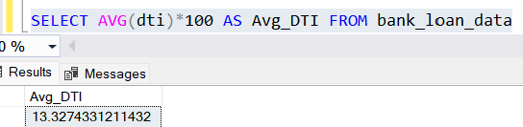

**MTD_Avg_DTI**

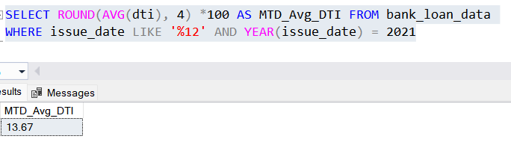

**PMTD_AVG_DTI**

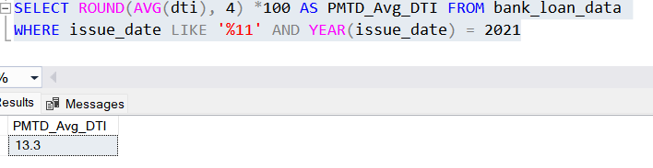

**Good_Loan_Percentage**

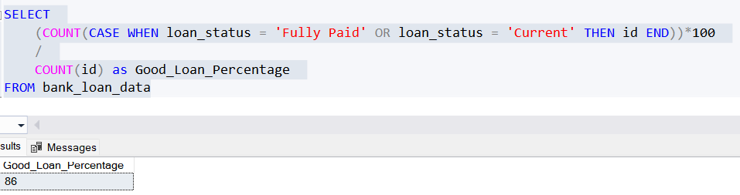

**Good_Loan_Applications**

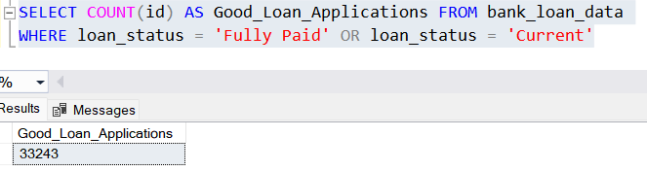

**Good_Loan_Funded_Amount**

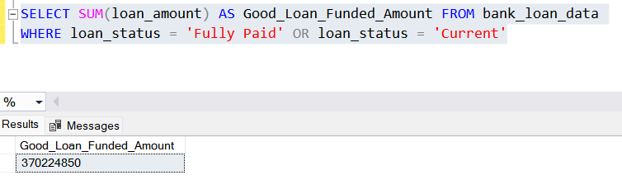

**Good_Loan_Received_Amount**

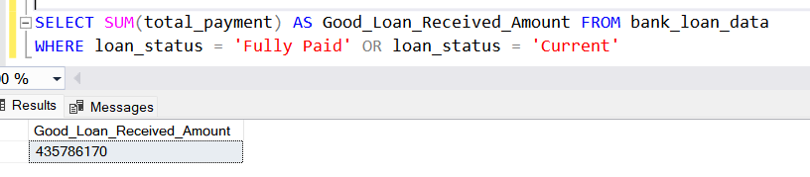

**Bad_Loan_Percentage**

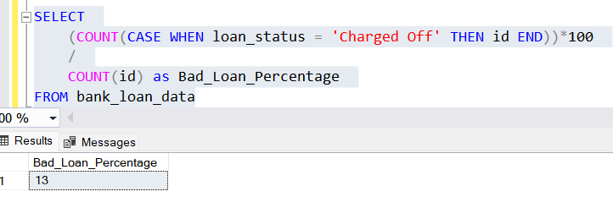

**Bad_Loan_Applications**

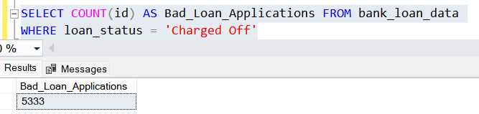

**Bad_Loan_Funded_Amount**

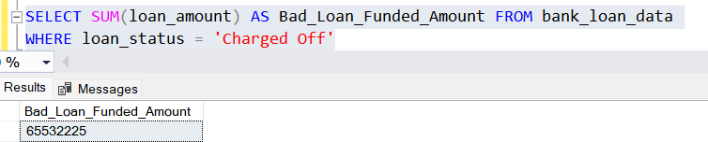

**Bad_Loan_Received_Amount**

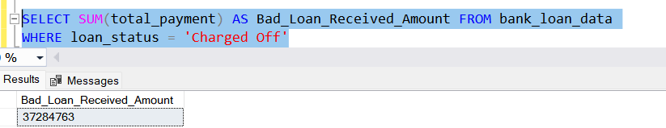

**LOAN STATUS**

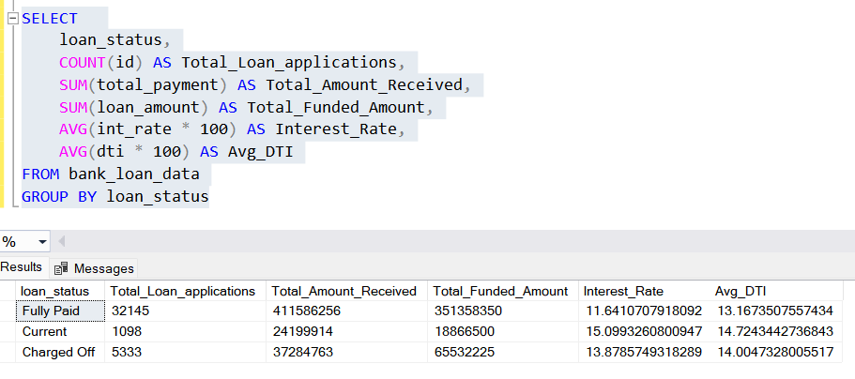

**MTD LOAN STATUS**

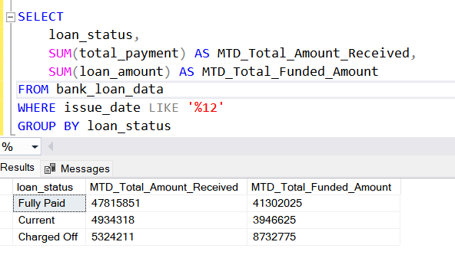

1. **CHARTS**

**Regional Analysis By State**

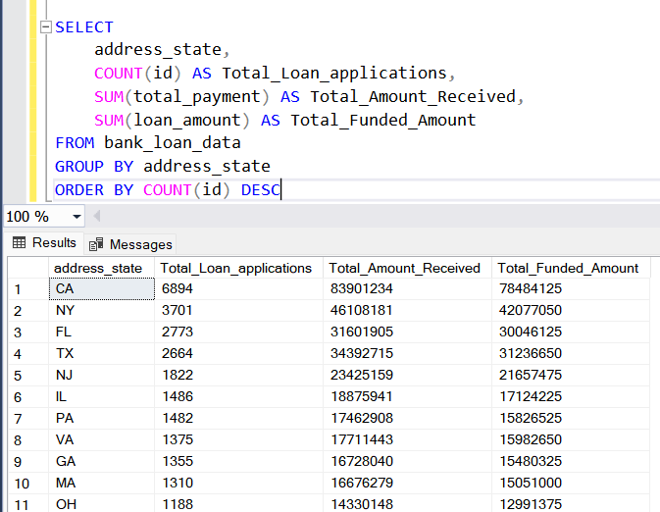

**Loan Term Analysis  
  
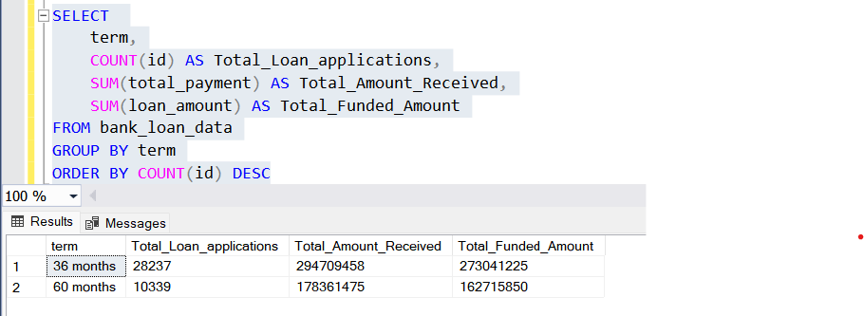**

**Employee Length Analysis  
  
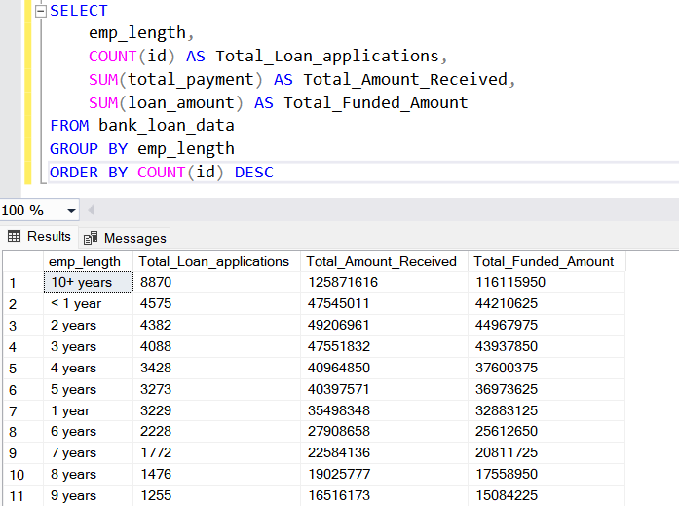**

**Loan Purpose Breakdown  
  
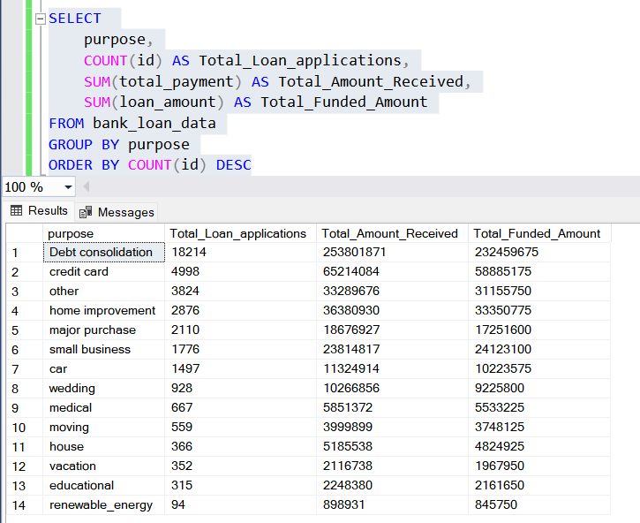**

**Home Ownership Analysis**

